To All European Nations

After the meeting held in Roana Sunday 30/08/2017 with the nations, and seeing the majority decision to insert from the next year, 2018, Figure for Minis and Espoir in Cup of Europe, I send here under in advance, the groups that the committee have approved/selected for these two categories and will be in function from the 01.01.2018.

ESPOIR

Figures: Gr.1 10 19 a/b 14
Gr.2 11 18 a/b 15
Gr.3 13 19 a/b 14

MINIS

Figures: Gr.1 3 6 a/b 8 a/b
Gr.2 4 5 a/b 9 a/b

Best Regards

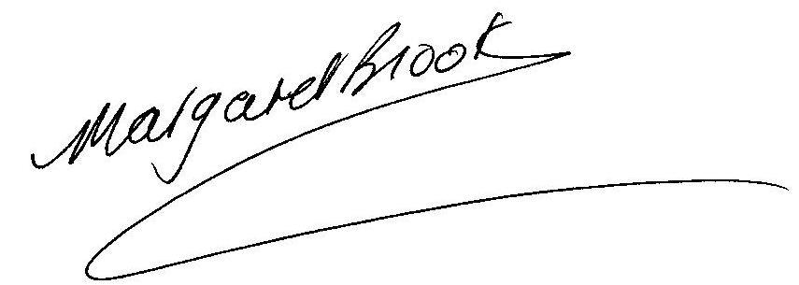
Margaret Brooks
CERS ATC President

